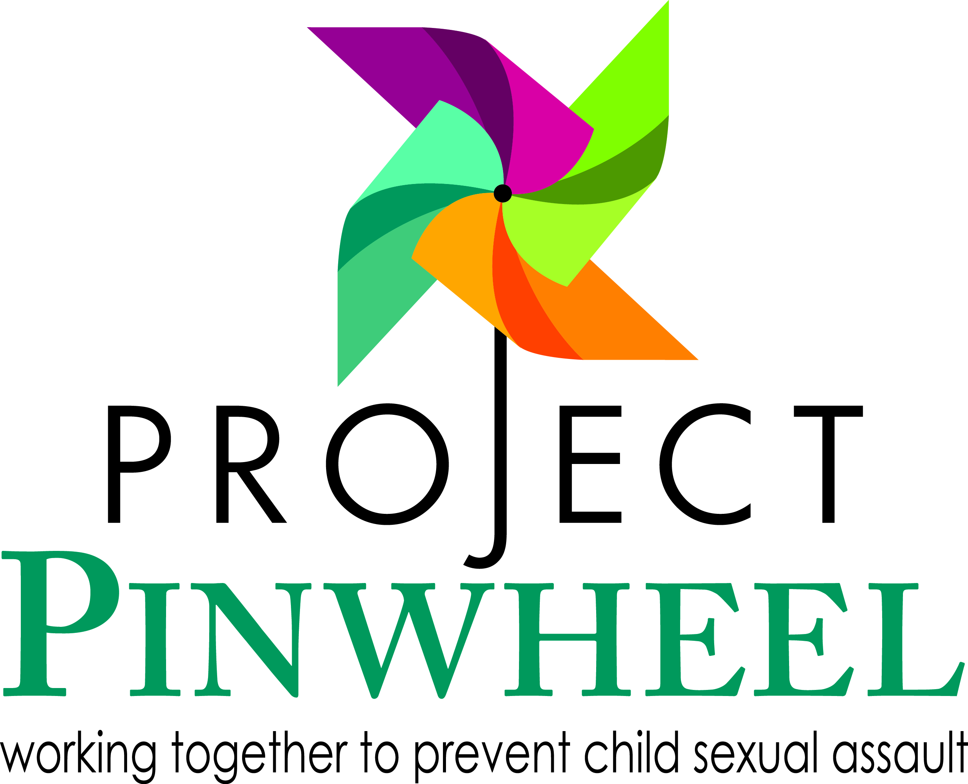
Recommended Reading List
Books for Children about Prevention
Federico, J. Some parts are not for sharing. Mustang. OK: Tate Publishing and Enterprises, LLC, 2008.
Freeman, L., & C. Deach. It’s my body: A book to teach young children how to resist uncomfortable touch. Seattle, WA: Parenting Press, 1982.
Hammerseng, K. Telling isn’t tattling. Seattle, WA: Parenting Press, 1995.
Hindman, Jan. A Very Touching Book…for little people and for big people, Alexandria Associates, 1983.

Johnsen, K. The trouble with secrets. Seattle, WA: Parenting Press, 1986.
Kleven, Sandy, LCSW. The Right Touch. Bellevue, Washington: Illumination Arts, 2010.
Spelman, C. Your body belongs to you. Morton Grove, IL: Albert Whitman & Company, 2000.
Walyoord- Girard, Linda. My Body Is Private . Albert Whitman & Company, 1984.

Books for Parents/Professionals about Prevention
Abel, G. The stop child molestation book: What ordinary people can do in their everyday lives to save 3 million children. Philadelphia, PA: Xlibris Corporation, 2001.
DeBecker, Gavin. Protecting The Gift: Keeping Children and Teenagers Safe (and Parents Sane). NY, NY: Dell Publishing 1999.
Hart-Ross, J. Protect your child from sexual abuse: A parent’s guide. Seattle, WA: Parenting Press, 1984.
Kraizer, S. The safe child book: A commonsense approach to protecting children and teaching children to protect themselves. New York: Simmon & Shuster, 1985.
Mahoney, Debbie & Romano, Branko. Innocence Lost? Protecting Your Child from the Trauma of Abuse.
Tschirhart-Sandford, L. The silent children: A book for parents about the prevention of child sexual abuse. New York: Anchor Books, 1980.
Wooden, Kenneth. Child Lures: What Every Parent and Child Should Know About Preventing Sexual Abuse and Abduction .
Wurtele, S.K., Ph.D. and F. Berkower M.S.W. Off Limits: A Parent’s Guide to Keeping Kids Safe from Sexual Abuse. Brandon, VT: Safer Society Press, 2010.
Materials for Survivors of Sexual Abuse
Adams, J. The colors within: One rainbow reclaimed. Philadelphia, PA: Xlibris Corporation, 2006.
Bailey Wright, L., & M. Loiselle. Back on track: Boys dealing with sexual abuse. Brandon, VT: The Safer Society Press, 1999.
Bass, Ellen & Thornton, Louise. I Never Told Anyone: Writings by Women Survivors of Child Sexual Abuse.
Blume, E. Sue. Secret Survivors: Uncovering Incest and Its Aftereffects in Women.
Kehoe, P. Something happened and I’m scared to tell: A book for young victims of abuse. Seattle, WA: Parenting Press, 1987.
Lewis-Herman, Judith. Father-Daughter Incest.

Satullo, Jane A.W, Russell, Roberta and Bradway, Pat. It Happens To Boys Too, 1987.

Books on Healing and Recovery (children & adults)
Adams, C. Helping your child recover from sexual abuse. Seattle, WA: University of Washington Press, 1992.
Bass Ellen & Davis Laura. The Courage to Heal: A Guide for Women Survivors of Child Sexual Abuse
Bonner, Barbara L., Ph.D. Taking action: Support for families of adolescents with illegal sexual behavior. Brandon, VT: Safer Society Press, 2009.
Brohl, K., and J. Case-Potter. When your child has been molested: A parents’ guide to healing and recovery. San Francisco, CA: Josey-Bass, 2004.
Davis, Laura. Allies in Healing: When the Person You Love Was Sexually Abused As a Child, A Support Book.
Davis, Laura. The Courage to Heal Workbook: For Women and Men Survivors of Child Sexual Abuse.
Feuereisen, P., and C. Pincus. Invisible girls: The truth about sexual abuse – A book for teen girls, young women, and everyone who cares about them. Berkeley, CA: Seal Press, 2005.
Gartner, R., and W. Pollack. Beyond betrayal: Taking charge of your life after boyhood sexual abuse. Hoboken, NJ: John Wiley & Sons Inc., 2005.
Gil, E. Outgrowing the pain: A book for and about adults abused as children. New York: Dell Publishing, 1983.
Hagans, Kathryn. When Your Child Has Been Molested: A Parent's Guide to Healing and Recovery.
Lew, Mike & Bass, Ellen. Victims No Longer: Men Recovering from Incest and Other Sexual Child Abuse.
Pithers, William, et al. From Trauma to Understanding: A Guide for Parents of Children with Sexual Behavior Problems, The Safer Society Program & Press. 1993

Spencer, Steven & White, Laurie. Take Care With Yourself, A Young Persons Guide to Understanding, Preventing and Healing from Abuse. 1998

Van Derbur, M. Miss America by day: Lessons learned from ultimate betrayals and unconditional love. Colorado: Oak Hill Ridge Press, 2004.
Wiehe, V. The brother/sister hurt: Recognizing the effects of sibling abuse. Brandon, VT: The Safer Society Press, 1996.
Sexuality Education Books: Young Children
Bassett, Kerry. My Very Own Special Body Book.
Brooks, R. and S. Perl. So that’s how I was born. New York: Simon & Schuster Books for Young Readers, 1983.
Brown, Laura Kransy, and Marc Brown. What’s the big secret? Talking about sex with girls and boys. Boston: Little, Brown Young Readers, 2000.
Cavanagh, T. Understanding children’s sexual behaviors: What’s natural and healthy. Oakland, CA: New Harbinger Publications, 1999.
Eyre, L., and R.Eyre. How to talk to your child about sex: It’s best to start early, but it’s never too late – A step-by-step guide for parents. New York: Golden Guides from St. Martin’s Press, 1999.
Holsten, Jon. The Swimsuit Lesson. Fort Collins, CO: Holsten Books, 2011.
King, Zack & Kimberly. I Said NO!. Weaverville, CA: Boulden Publishing, 2010.

Mayle, P. Where did I come from? New York: Lyle Stuart Books, 2000.
Miller, Patricia Martens. Sex Is Not A Four-Letter Word!: Talking Sex With Your Children Made Easier. New York: NY, Crossroad Publishing, 1994.
Richardson, J., and A. Schuster. Everything you never wanted your kids to know about sex, but were afraid they’d ask: The secrets to surviving your child’s sexual development from birth to the teens. New York: Crown Publishers, a division of Random House Inc., 2003.
Ryan, Gail & Blum, Joanne. Childhood Sexuality – A Guide for Parents, Kempe Children’s Center.

Starishevsky, Jill. My Body Belongs to Me. NY, NY: Safety Star Media, 2007.

Sexuality Education Books: Preteens
Cole, J. Asking about sex and growing up: A question and answer book for boys and girls. New York: HarperCollins, 1988.
Gitchel, S., and L. Foster. Lets talk about S-E-X. Minnetonka, MN: Book Peddlers, 2005.
Madaras, L. The “what’s happening to my body?” book for boys. New York: Newmarket, 2007
Madaras, L. The “what’s happening to my body?” book for girls. New York: Newmarket, 2007.
Mayle, P. What’s happening to me. Answers to the world’s most embarrassing questions. Secaucus, NJ: L. Stuart, 1975.
Sexuality Education Books: Parents and Teens
Bell Alexander, R., and L. Zeigler-Wildflower. Talking with your teenager. A book for parents. New York: Random House Press, 1983.
Calderone, M., and E. Johnson. Family book about sexuality. New York: Harper and Row, 1981.
Howard, M. How to help your teenager postpone sexual involvement. New York: Continuum Publishing Company, 1988.
Roddman, Deborah M. Sex & Sensibility: The Thinking Parent’s Guide to Talking Sense about Sex.
Sutton, R. Hearing us out: Voices from the gay and lesbian community. Toronto: Little Brown and Company, 1997
The Medical Institute for Sexual Health; Cox, Melissa R., editor. Questions Kids Ask About Sex: honest answers for every age. Grand Rapids, MI: Revell, 2005.

